**Health Status Dashboard**

* Created a Health Status Dashboard
* A top-level summary row and individual panels for three services: Order Management, Account Management, and Product Config.
* Multiple data transformations have been applied to aggregate key metrics such as Total Requests, Service Availability, and Success/Error percentages.
* The panels are also styled with conditional formatting and color thresholds to provide clear analysis for health status.

**Drill Down Feature**Implement drill-down functionality in this Dashboard for the error code panels to provide more granular insights

* Implemented a **drill-down dashboard flow** in Grafana to analyze errors in detail.
* Added **dashboard variables** (service, error_class) for dynamic filtering across panels.
* Built an **Error Details dashboard** that displays error_code, count, timestamp, request_id, endpoint, and message.
* Configured **data links** from 4xx and 5xx panels in the main dashboard to the Error Details dashboard for one-click navigation.
* Ensured that filters (service + error type) are passed automatically when clicking the link.

Main dashboard for error details

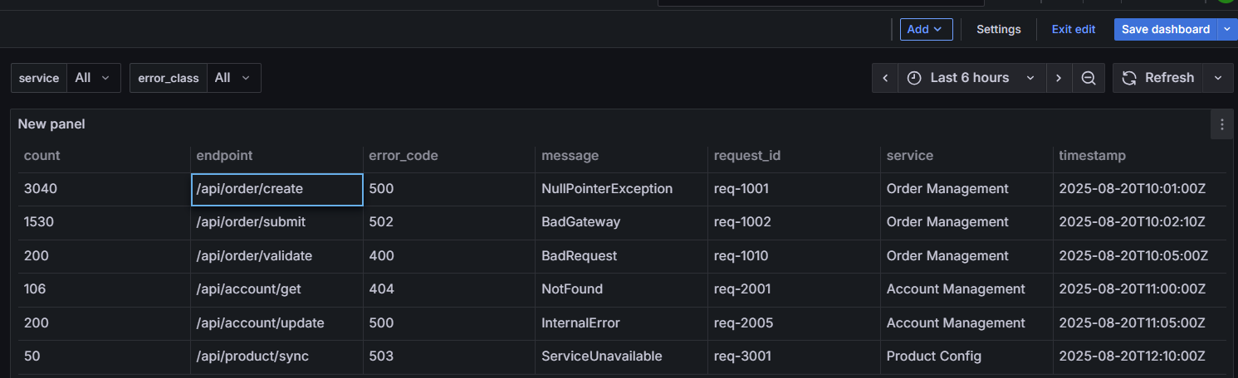

Each service 4xx ( client error) navigation to error details dashboard using drill down

Each service 5xx ( server error) navigation to error details dashboard using drill down

